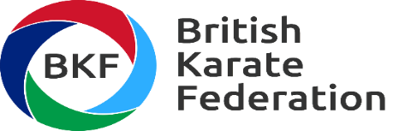

Where We are
BKF Karate History
BKF competed in the 1st International Karate competition held in Paris in 1963.
In 1966 the European Karate Union was formed and the 1st European Karate Championships was held in Paris

In 1970 the 1st World Karate Championships were held in Tokyo Japan

In 1992 the SCAGMA (Sports Council Agreement Governing Martial Arts) agreement was enacted by the 4 Home Nation Karate NGB’s.

In August 2016 Karate was included as a sport for the 2020 Tokyo Olympics.

In March 2019 BKF became an incorporated company.

BKF Operation

The BKF is the National Karate Federation recognised by the World Karate Federation (the International Federation for Karate recognised by the IOC) and is the umbrella organisation for the 4 Home Country Karate NGB’s.

BKF is a not for profit membership company limited by guarantee, committed to support & develop British Karate.

BKF is responsible for the Olympic selection and performance of the British Karate squads and their participation in Olympic Events and relevant tournaments.

The BKF holds regular meetings with its stakeholders to discuss items such as technical and political issues relating to Karate, and represents the 4 Home Country Karate NGB’s in discussions with UK Sport (UKS) and British Olympic Association (BOA).

The BKF holds two off (2) Karate championships per year i.e. the 4 Nations Home Championships and the BKF International Open Championships.

BKF Commitment to Equal Opportunities

BKF Ltd is fully committed to the principles of equality of opportunity and is responsible for ensuring that no applicants for volunteer positions, office holders, volunteers, consultants, members are unlawfully discriminated against because of age, disability, gender or gender reassignment, religion or sexual orientation.

