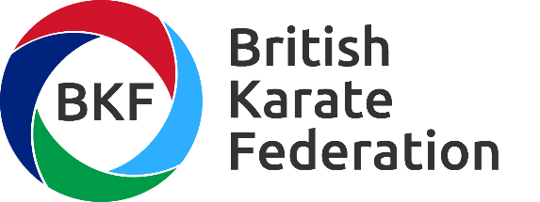

Stakeholder Engagement Strategy

INTRODUCTION
What is a stakeholder?
A stakeholder is any individual, groups of individuals or organisations that affect or could be affected by BKF Ltd activities and/or performance.
What do we mean by Engagement?
Engagement isn’t just speaking to people... it is how we listen to what is being said to us and what we do with that information. How do we allow our stakeholders to influence how we conduct our business and change our policies and procedures? We listen to what they want and need to change our operations to fit the needs of our stakeholders and provide a better service.
Stakeholder engagement is the process by which we involve stakeholders, and engage with them to identify and understand their issues and needs, thereby allowing them to influence our business decision making and business change to provide the highest possible standard of service, and one that fits their requirements.
If we are engaging with our stakeholders and understanding the environment around us we will be able to identify, how we can best work together.
Stakeholder
Engagement is all about connectedness, or creating a closer relationship with your audience, or in our case, our membership.

AIM OF THE STAKEHOLDER ENGAGEMENT STRATEGY
The aim of our stakeholder engagement strategy is to provide a framework to operate within, to improve the performance of the organisation by seeking out stakeholder input, listening to and acting on stakeholder feedback.
Stakeholder engagement is used to support both operational and strategic improvements in performance. Ultimately this helps us to deliver a better service for our members now and into the future.
It is critical that our stakeholder engagement activity is embedded into our organisation and is relevant, addressing strategic issues and is focussed in areas where stakeholders can really influence what we do, only then will we establish the level of engagement that will deliver real benefits for both the business and stakeholders.

Stakeholder Matrix

Stakeholder | Coding | Areas of influence /interest | Engagement Approach | Engagement Tools | Frequency
Members |  | Governance, strategy, competitions, licensing & insurance | Consult | AGM, website, & emails | Very frequent
Home country sport councils |  | Leadership & development | Consult | Face to face, & emails | More Frequent
UK Sport |  | Funding &  Governance Compliance | Consult | Face to face & emails | Frequent
World & European Karate Federations |  | Competition, regulations and political oversight | Consult | World Congress, emails | Less frequent
Sponsors & suppliers |  | Competitions & competitors | Consult | Face to face & emails | Occasional

