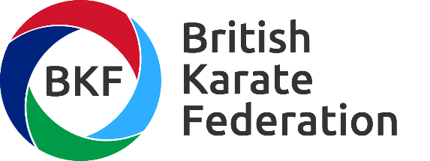

Governance Statement

The BKF are firmly committed to maintaining the highest standards of corporate governance. We are committed to the UK Sport Governance Code and we are restructuring our operational methodologies to reflect how the BKF will apply the principles of the Code.
The BKF fully understand the value of good corporate governance to and its link to long-term sustainable success.
Having incorporated in 2019 we will undertake an internal Board evaluation focusing on the overall effectiveness of the Board and its Committees. The results of this evaluation will be incorporated into the future work of the Board.
The Board is responsible for the stewardship of the BKF, risk management and overseeing its strategy to long term sustainability.
The collective estimated membership of approximately 40,000 registered shareholders, and engagement with the 4 home country Sport Councils, UK Sport British Olympic Association, European & World Karate Federations requires detailed consideration in Board discussions and decision making.
We believe that the BKF reputation will be judged by how we engage with all of these stakeholders and a strong relationship with all of our stakeholders will ensure the sustainable success of the BKF.

